**A**

**Project Report**

**On**

# “INTERMITTENT CONVEYOR SYSTEM”

# Submitted by:

# MR. BUSARI SAGAR SANJAY ( B150980854 )

# MR. JADHAV RAHUL VIJAY ( B150980828 )

# MR. RAUT MAYUR SHIVAJI ( B150980849 )

# MR. SAYYAD ALIM ASLAM ( B150980859 )

**Under the Guidance of**

## Asst. Prof. BORA T. A.

**Adsul’s Technical Campus Chas, Ahmednagar - 414005**

**2021-2022**

Adsul’s Technical Campus Chas, Ahmednagar - 414005

# 

# CERTIFICATE

This is to certify that,

# MR. BUSARI SAGAR SANJAY ( B150980854 )

# MR .JADHAV RAHUL VIJAY ( B150980828 )

# MR. RAUT MAYUR SHIVAJI ( B150980849 )

# MR. SAYYAD ALIM ASLAM ( B150980859 )

Has successfully completed the seminar work entitled **“INTERMITTENT CONVEYOR SYSTEM”** under my guidance and Supervision in the partial fulfillment of Bachelor of Engineering – Mechanical Engineering of Savitribai Phule Pune University, during AY. 2021-2022

Date: / / 2022

Place : Chas, Ahmednagar.

**(Project Guide) (H.O.D. Mechanical Department)**

**External Examiner Principal**

**ACKNOWLEDGEMENT**

Every orientation work has imprint of many people and this work is no different. This work gives us an opportunity to express deep gratitude for the same.

While working on the project, we received endless help from a number of people. This work would be incomplete if we don’t convey our sincere thanks to all those who were involved.

First and foremost we would like to thank our Respected Guide and H.O.D. Mechanical Engineering for their valuable guidance.

We are thankful for their indispensable support, priceless suggestions, endless motivation and valuable time.

Finally, we would like to thank our friends and our families for being supportive, without whom this project would not have seen the light of day.

Every work is an outcome of full-proof planning, continuous hard work and organized

Effort.

# MR. BUSARI SAGAR S. ( B150980854 )

# MR . JADHAV RAHUL V. ( B150980828)

# MR .RAUT MAYUR S. ( B150980849 )

# MR. SAYYAD ALIM A. ( B150980859 )

**ABSTRACT**

There has been a serious demand for intermittent movement of packages in the industries right from the start. Though the continuous movement is more or less important in the same field the sporadic motion has become essential. The objective of our project is to produce a mechanism that delivers this stop and move motion using mechanical linkages. The advantage of our system over the conveyor system is that the system has a time delay between moving packages and this delay can be used to introduce any alterations in the package or move the package for any other purpose and likewise. While in conveyor system such actions cannot be performed unless programmed module is used to produce intermittent stopping of the belt which basically is costly. So in the project we have introduced rack and pinion arrangement and intermittent motion of rack is achieved by sector gear.

***Keywords*** – intermittent motion, sector gear, rack and pinion.

**INDEX**

|  |  |  |
| --- | --- | --- |
| **Chapter No.** | **Name of Chapter** | **Page No.** |
| 1 | INTRODUCTION | 7 |
| 2 | LITURATURE SURVEY | 9 |
| 3 | METHODOLOGY | 15 |
| 4 | CONSTRUCTION & WORKING | 26 |
| 5 | DESIGN OF PROJECT | 28 |
| 6 | MANUFACTURING PROCESSES SHHET | 31 |
| 7 | COST ESTIMATION | 34 |
| 8 | OUTCOMES OF PROJECT | 36 |
| 9 | FUTURE SCOPE | 37 |
| 10 | CONCLUSION | 39 |
|  | REFERENCES | 40 |

**LIST OF FIGURE**

|  |  |  |  |
| --- | --- | --- | --- |
| **Sr. No.** |  | **Name of Figure** | **Page No.** |
| 1 |  | Geneva Operated Intermittent Mechanisms | 11 |
| 2 |  | Crank Mechanisms Conveyor | 12 |
| 3 |  | CAD Modelling of Geneva operated conveyor | 13 |
| 4 |  | Rack and Pinion unit of conveyor | 15 |
| 5 |  | Type of Bed Conveyor | 19 |
| 6 |  | DC Motor | 24 |
| 7 |  | AC to DC Convertor Circuit | 26 |
| 8 |  | Construction & Working of Project | 28 |
| 9 |  | Various Manufacturing Process Related to Project | 32 |

**Chapter No.-1**

**INTRODUCTION**

Material handling is defined by the Material Handling Industry of America as "the movement, storage, protection and control of materials throughout the manufacturing and distribution process including their consumption and disposal". The handling of materials must be performed safely, efficiently, at low cost, in a timely manner, accurately and without damage to the materials. Material handling is an important yet often overlooked issue in production. The cost of material handling is a significant portion of total production cost, estimates averaging around 20-25% of total manufacturing labor cost. The proportion varies, depending on the type of production and degree of automation in the material handling function.

Material handling cannot be avoided in logistics, but can certainly be reduced to minimum levels. The productivity potential of logistics can be exploited by selecting the right type of handling equipment. The selection of material handling equipment cannot be done in isolation, without considering the storage system. Investment in the material handling system will be sheer waste if it is not compatible to the warehouse layout plan. The layout will create obstacles for free movement of equipment and goods, resulting in poor equipment productivity. Recent trends indicate preference for automated system with higher logistics productivity to enhance the effectiveness of human energy in material movement.

Conveyor is used in many industries to transport goods and materials between stages of a process. Using conveyor systems is a good way to reduce the risks of musculoskeletal injury in tasks or processes that involve manual handling, as they reduce the need for repetitive lifting and carrying. Conveyors are a powerful material handling tool. They offer the opportunity to boost productivity, reduce product handling and damage, and minimize labor required in a manufacturing or distribution facility.

**OBJECTIVE**

There has been a serious demand for intermittent movement of packages in the industries right from the start. Though the continuous movement is more or less important in the same field the sporadic motion has become essential. The objective of our project is to produce a mechanism that delivers this stop and move motion using mechanical linkages. The advantage of our system over the conveyor system is that the system has a time delay between moving packages and this delay can be used to introduce any alterations in the package or move the package for any other purpose and likewise. While in conveyor system such actions cannot be performed unless programmed module is used to produce intermittent stopping of the belt which basically is costly.

**Chapter No.-2**

**LITERATURE SURVEY**

**Mukkavar et. al**. Geneva mechanism is a system to convert continuous circular motion into fixed step circular motion. Fixed step circular motion in other words means a circular motion produced in equal spaces of time and resulting in the same displacement which is a requirement in many automation industries. A conveyer belt is simply a linear belt mostly made up of rubber (of greater stability). It has a basic function of transporting raw material/ material in process of manufacturing. A simple Geneva mechanism consists of a drive wheel and a driven wheel. The drive wheel is a disk with a pin or a shaft near it’s circumference. The driven wheel consists of several slots. The drive wheel is kept next to the driven wheel in such a way that when the drive wheel is rotated, the pin or shaft fits inside the slot. As it reaches the bottom most point of the slot, the pin exerts a force on the driven wheel. As the driven wheel is pivoted from the centre, there will be a generation of a moment. This causes the generation of a torque which rotates the driven wheel. Hence there is a fixed step circular motion. There are several types of Geneva rotator such as external Geneva rotator, internal Geneva rotator and spherical Geneva rotator. Geneva mechanism is one of the most simple and inexpensive mechanisms. The mechanism used for conveyer belt is an external Geneva mechanism. This mechanism gives out production of jerks or instantaneous change in acceleration. The mechanism has various applications in many industries especially the automation/automobile industry. Modern day film projectors use a variation of this mechanism to power a motor which is used for fast forwarding. In short the Geneva mechanism converts continuous rotatory motion of the drive wheel to intermittent rotatory motion of the gear. A cheap, convenient and a simple mechanism with a variety of applications.

Geneva mechanism is a system to convert continuous circular motion into fixed step circular motion. Fixed step circular motion in other words means a circular motion produced in equal spaces of time and resulting in the same displacement. Simple Geneva mechanism consists of a drive wheel and a driven wheel. The drive wheel is a disk with a

pin or a shaft near it’s circumference. The driven wheel consists of several slots. The drive wheel is nothing but a motor which has a plastic rod with a small rod extruded at its apex. The drive wheel is kept next to the driven wheel in such a way that when the drive wheel is rotated, the extruded rod fits inside the slot. As it reaches the bottom most point of the slot, the rod exerts a force on the driven wheel. As the driven wheel is pivoted from the centre, there will be a generation of a moment. This causes the generation of a torque which rotates the driven wheel. Hence there is a fixed step circular motion. The mechanism used for conveyer belt is an external Geneva mechanism. This mechanism gives out production of jerks or instantaneous change in acceleration. In short the Geneva mechanism converts continuous rotatory motion of the drive wheel to intermittent rotatory motion of the gear.



Fig.2.1 geneva operated intermittent mechanism

**Sivakumar et. al.** That machine is basically works on the principle of Single Slider Crank Mechanism. Which is the heart of this machine and it converts rotary motion into a reciprocating motion.This mechanism do not includes strong belts, pulleys and heavy motors to rotate the pulley to move the conveyor. As an alternative to this conveyor type, more simple and comfortable machine using four bar mechanism can be used. This box shifting machine helps in transfer of boxes smoothly by use of four bars with a simple

arrangement. The four bar mechanism includes four links. One link is fixed and the other links act as crank, follower and connecting rod. The rotary motion of the crank is transferred to the follower by using connecting rod and is converted to the same rotary motion. This machine requires an electric motor to provide input to the system.

In this machine can comfortable for moving the product from one place to another place with safely. The machine is placed and working process is very easy for using persons. In this machine , the control unit is control the motor drive for rotation of the crank shaft .The motor is placed and the crank shaft is attached with the motor with the help of bearing. The products are safely placed in the stored place and then motor is ON , the crank is rotated and the first box is move from first place to second place in the first rotation , after that the second box is placed in the first position , the second rotation is started the first box is move from second place to third place , in the mean time the second box is move from first place to second place . In this based the boxes are move from one place to another place simultaneously .The products are safely transfer from one place to another in conveyor using crank mechanism.



Fig. 2.2 Crank mechanism conveyor

**Ingalkar et.al.** they have successfully calculated the angular velocity and acceleration of the Geneva wheel. For the designed Genera wheel the and roller conveyor the time required by the material to cross the entire belt is calculated accurately. The entire modeling of the project is done with the help of CATIA V5R20. In addition to this. The project work has provided us an excellent opportunity and experience, to use our limited knowledge. they gained a lot of practical knowledge regarding, planning, purchasing, assembling and machining while doing this project work. They feel that the project work is good solution to bridge the gates between institutions and industries. They were proud that we have completed the work with limited time successfully. “The Geneva Operated Roller Conveyor” is working with satisfactory condition. Thet have done to our ability and skill making ma work, let us add. The proposed concept wills a few more lines about our impression project work. Help in production line where many workers are used for the material handling purpose it also reduce the cost and threshing time requirement of more number of worker will be completely eliminated as only two workers can carried out the complete operation. The project objective originally is to convey the material handling at regular interval of time. The in future the complete stress analysis of the project model could be done. This analysis could be done



Fig.2.3 CAD modeling of Geneva Operated Roller Conveyor

**Sanjay et. al.** In their project they are using the Geneva conveyor for material handling and noise reduction in industries. It consists of motor, rollers, belt and IR sensor. Two rollers are mount on the stand, according to the required distance. The belt is mount on the rollers on which the materials are placed. The roller shaft is coupled with the Geneva drive. The Geneva drive shaft is coupled with the motor shaft, hence when power is supplied to the motor the rollers rotate with a certain time stoppage according to the Geneva drive and the belt moves along the rollers. Thus material handling is carried out. With the help of Geneva drive, the time stoppage can be achieved which avoids the use of stepper motor thus reduces the cost involved. The main aim of this project is to optimize the measuring length of work piece and to reduce the noise of conveyor. Normally the plug gauges are used to inspect the components. Instead of using manual inspection, automatic system via pneumatic comparators is used.

When the electrical supply is given to dc motor, shaft of the motor tends to rotate. The rollers shaft is coupled with the Geneva drive. The Geneva drives shaft is coupled with the motor shaft hence when power is supplied to the motor rollers rotate with a certain time delay according to the Geneva drive and the belt moves along the rollers. Thus material handling is carried out. Conveyor is used for carrying the objects from one end to another end. We have IR sensor in conveyor for detect the objects when they comes. If the object is detected means it will send a low pulse to Micro controller. Then the controller can identify the object is came and analyzes the quality.

Then the controller can identify the object is came and analyzes the quality. If the object is bad quality means it will on the DC motor to rotate the rod in to place in the bad quality box. If the object is 1st quality means the controller will not ON the DC motor. So the object can be placed in the 1st quality box, which is in the conveyors another end. This Process will go repeatedly when sensor sense the another object.

**Raji et. al.** The design analysis of a conveyor mechanism for an automatic car park is discussed. A prototype of the conveyor mechanism is fabricated to demonstrate the automation involved in the design and construction of an automatic car park system for local application. The conveyor assembly is made up of three units; the rack-pinion unit

the cable drive unit and the cantilever. The rack-pinion unit converts the rotational motion of a stepper motor to a linear forward and backward motion of the conveyor. The pinion-rack design for strength and rigidity is considered for the load required to be translated by the conveyor. The prototype was interfaced with a computer for operation using parallel port.



Fig.2.5 Rack Pinion unit of conveyor

**Chapter No.-3**

**METHODOLOGY**

**3.1 RACK & PINION**

A rack and pinion is a type of [linear actuator](https://en.wikipedia.org/wiki/Linear_actuator) that comprises a pair of [gears](https://en.wikipedia.org/wiki/Gear) which convert rotational motion into linear motion. A circular gear called "the [pinion](https://en.wikipedia.org/wiki/Pinion)" engages teeth on a linear "gear" bar called "the rack"; [rotational](https://en.wikipedia.org/wiki/Rotation) motion applied to the pinion causes the rack to move relative to the pinion, thereby translating the rotational motion of the pinion into linear motion.

For example, in a [rack railway](https://en.wikipedia.org/wiki/Rack_railway), the rotation of a pinion mounted on a [locomotive](https://en.wikipedia.org/wiki/Locomotive) or a [railcar](https://en.wikipedia.org/wiki/Railcar) engages a [rack](https://en.wikipedia.org/wiki/Rack_railway#Rack_systems) between the rails and forces a [train](https://en.wikipedia.org/wiki/Train) up a steep [slope](https://en.wikipedia.org/wiki/Grade_(slope)). Rack and pinion combinations are often used as part of a simple linear actuator, where the rotation of a shaft powered by hand or by a motor is converted to linear motion.

The rack carries the full load of the actuator directly and so the driving pinion is usually small, so that the gear ratio reduces the torque required. This force, thus torque, may still be substantial and so it is common for there to be a reduction gear immediately before this by either a gear or worm gear reduction. Rack gears have a higher ratio, thus require a greater driving torque, than screw actuators.

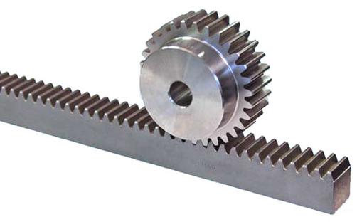

Fig.3.1 Rack and Pinion gear pair

Gear racks are utilized to convert rotating movement into linear motion. A gear rack has straight teeth cut into one surface of a square or round section of rod and operates with a pinion, which is a small cylindrical gear meshing with the gear rack. Generally, gear rack and pinion are collectively called “rack and pinion”. There are many ways to use gears. For example, as shown in the picture, a gear is used with the gear rack to rotate a parallel shaft.

To provide many variations of rack and pinion, KHK has many types of gear racks in stock. If the application requires a long length requiring multiple gear racks in series, we have racks with the tooth forms correctly configured at the ends. These are described as “gear racks with machined ends”. When a gear rack is produced, the tooth cutting process and the heat treatment process can cause it to try & go out of true. We can control this with special presses & remedial processes.

There are applications where the gear rack is stationary, while the pinion traverses and others where the pinion rotates on a fixed axis while the gear rack moves. The former is used widely in conveying systems while the latter can be used in extrusion systems and lifting/lowering applications.

As a mechanical element to transfer rotary into linear motion, gear racks are often compared to ball screws. There are pros and cons for using racks in place of ball screws. The advantages of a gear rack are its mechanical simplicity, large load carrying capacity, and no limit to the length, etc. One disadvantage though is the backlash. The advantages of a ball screw are the high precision and lower backlash while its shortcomings include the limit in length due to deflection.

Rack and pinions are used for lifting mechanisms (vertical movement), horizontal movement, positioning mechanisms, stoppers and to permit the synchronous rotation of several shafts in general industrial machinery. On the other hand, they are also used in steering systems to change the direction of cars. The characteristics of rack and pinion systems in steering are as follows: simple structure, high rigidity, small and lightweight, and excellent responsiveness. With this mechanism, the pinion, mounted to the steering

Shaft is meshed with a steering rack to transmit rotary motion laterlly (converting it to linear motion) so that you can control the wheel. In addition, rack and pinions are used for various other purposes, such as toys and lateral slide gates.

**3.2 BELT CONVEYOR**

A conveyor belt is the carrying medium of a belt conveyor system. A belt conveyor system is one of many types of conveyor systems. A belt conveyor system consists of two or more pulleys, with an endless loop of carrying medium the conveyor belt that rotates about them. One or both of the pulleys are powered, moving the belt and the material on the belt forward. The powered pulley is called the drive pulley while the unpowered pulley is called the idler pulley. There are two main industrial classes of belt conveyors. Those in general material handling such as those moving boxes along inside a factory and bulk material handling such as those used to transport large volumes of resources and agricultural materials, such as grain, salt, coal, ore, sand, overburden and more.

Belt conveyors are universally used in industrial settings and in packaging and assembling units. They can help in transportation of regular and irregularly shaped items from one point to another regardless of their weight. The items can travel in a horizontal, declined or inclined manner, depending on the type of belt conveyor used. They are placed on the surface of the conveyor and transported from one point to the other through continuous, non-stop movement.

The belt conveyor comprises of a belt that rests on top of a smooth metal bed or rollers. When the distance is long, belt conveyors with rollers are the most suitable option, as the rollers help to reduce friction. It is not necessary for belt conveyors to be straight. They also can turn corners with a special attachment. In such a case, the shape of the belt for the corners will be concentric, to facilitate smooth movement around the corners.

**TYPES OF BELT CONVEYOR**

There are many different types of conveyors and companies should be able to find one to suit their needs. Some of the most common types are discussed below.

**3.2. 1 Roller bed conveyor**

As the name suggests, in this type of belt conveyor, the surface for the belt comprises of rollers. The rollers are selected based on the load of the items to be transported and the required speed of the belt. Usually there are two rollers in a short belt conveyor. However, the number of rollers may increase if the distance between the two ends of the belt conveyor is more. Typically, these belt conveyors are used when the items are loaded onto it with gravity rather than manually. Manual loading can cause mechanical shock to the rollers, resulting in damage. It is shown in figure



Fig.3.2.1 Roller bed conveyor

**3.2.2 Horizontal belt conveyor**

This type of belt conveyor consists of a centre drive, gear motor, and take-up. Based on the drive of the conveyor, it can come with one or two pulleys at the end. The belt of the conveyor is flexible and the entire system has floor supports along its length. The figure shows the horizontal belt conveyor.



Fig. 3.2.2 Horizontal belt conveyor

**3.2.3 Incline and Decline conveyor**

This type of conveyor is similar to a horizontal belt conveyor, but has an additional component. It comes with a single or double nose over and sometimes it also has a feeder portion. Typically, this type of conveyor has a rough surface on the belt during incline or decline rather than making use of a smooth-surfaced belt. This offers more traction to the items placed on the conveyor and prevents them from rolling backwards or forwards. The figure 3.2.3 shows this type of conveyor.



Fig. 3.2.3 Incline and Decline conveyor

**3.2.4 Brake and Meter belt conveyor**

This conveyor comprises of two parts. The brake belt is installed at the end of the conveyor and facilitates accumulation of the items, while the meter belt is used to separate items. Typically, the meter belt has the drive, whereas the brake belt uses the slave drive from the meter belt. The length of the brake and meter belt is very important. Typically, it should be about 1/7th of the total length of the accumulation conveyor and this includes brake and meter belt lengths too. It is shown in below figure 3.2.4



Fig.3.2.4 Brake and Meter belt conveyor

**3.2.5 Metal Piano Hinge conveyor**

This is a hinged type belt conveyor made from steel. It is perfect for transporting hot and oily components from a punch press and forging machines. It is shown in figure 3.2.5 in below. This type of belt conveyor can be horizontal, inclined into an ‘S’ shape or even level.



Fig. 3.2.5 Metal Piano Hinge conveyor

**3.2.6 Wire Mesh belt conveyor**

As the name suggests, it has mesh that will facilitate air ventilation. Hence, this type of belt conveyor is ideal for transporting hot and cold items or components that cannot be handled using standard duck or PVC belts. The wire mesh is placed on roller or longitudinal runners and then it is covered with a thick plastic. In addition, there are toothed pulleys to clasp onto the wire mesh belt. It is shown in figure



Fig.3.2.6 Wire Mesh belt conveyor

**3.2.7 Portable conveyor**

This conveyor comes with caster wheels allowing it to be rolled from one place to another. There are different types of portable conveyors and most companies can find one to suit their needs. There are even portable gravity conveyors that can be extended depending on the customer’s needs. The figure shows the portable conveyor.

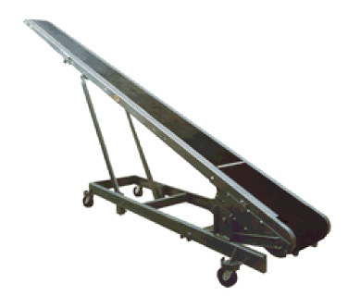

Fig.3.2.7 Portable conveyor

**3.3 DC MOTOR**

A DC motor is any of a class of electrical machines that converts direct current electrical power into mechanical power. The most common types rely on the forces produced by magnetic fields.

windscreen wiper or windshield wiper is a device used to remove rain and debris from a windscreen or windshield. Almost all motor vehicles, including trains, watercraft and some aircraft, are equipped with such wipers, which are usually a legal requirement. A wiper generally consists of an arm, pivoting at one end and with a long rubber blade attached to the other. The blade is swung back and forth over the glass, pushing water from its surface. The speed is normally adjustable, with several continuous speeds and often one

or more "intermittent" settings. Most automobiles use two synchronized radial type arms, while many commercial vehicles use one or more pantograph arms.



Fig 3.3 DC Motor

## 3.4 AC TO DC CONVERTER

There are different types of [power electronics](http://www.efxkits.co.uk/wireless-sensor-networks-based-projects-for-electronics-beng/) converters such as rectifier, inverter, voltage regulator, F to V converter, cycloconverter, and so on. The power electronics converter which is used for converting AC to DC is called as rectifier circuit. The maximum number of electronic circuits are using DC power for their operation and let us consider the microcontrollers (8051 microcontrollers are typically used in maximum number of microcontroller based projects or circuits) which require 5V DC regulated power supply.

There are different circuits that can be used for converting the available 230V AC power to 5V DC power using various techniques. Generally, the step-down converters can be defined as converters with output voltage less than the input voltage. Let us discuss about AC to DC converter (here considering a frequently used converter in the power supply circuit, 230V AC to 5V DC converter) and its working in detail.

### 4-Simple Steps to Convert AC to DC

#### 1. Stepping down the Voltage Levels

The step-up transformers are used for stepping up the voltage levels and [step-down transformers](http://www.efxkits.co.uk/android-home-automation-system/) are used for stepping down the voltage levels. Thus, by using a step-down transformer the available 230V AC power supply is converted into 12V AC. The output of this step-down transformer is RMS value and its peak value can be given by the product of the square root of two and RMS value, and is approximately equal to 17V.

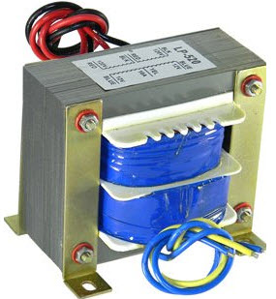

Fig.3.4.1 Step-down Transformer

There are two windings in the step-down transformers, primary and secondary windings in which primary winding consists of more number of turns compared to the secondary winding (less number of turns). We know that, transformer works based on the principle of Faraday’s laws of [electromagnetic induction](http://www.efxkits.co.uk/sub-ghz-wireless-communications/).

#### 2. AC to DC Power Converter Circuit

Primarily, the 230V AC power is stepped-down to 12V AC (12V RMS value of which the peak value is 17V approximately), but 5V DC is the required power. So, this stepped-down output 17V AC power has to be converted into DC power and then it is to be stepped down to 5V DC. AC to DC converter namely rectifier is used for converting the 17V AC into DC and there are different types of rectifiers, such as half-wave, full-wave, and bridge rectifiers. [Bridge rectifier](http://www.efxkits.co.uk/light-activated-switch-circuit/) is mostly preferred compared to the half wave, full wave, and bridge rectifiers.

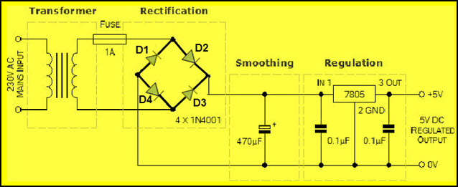

Fig.3.4.2 AC to DC Converter Circuit

The rectifier which consists of four diodes and are connected in the form of bridge is called as a bridge rectifier. We know that, the diode conducts only in one direction (during forward bias only), remains in off state in another direction (during reverse bias). Diode generally are uncontrolled i.e., whenever the anode voltage becomes greater than the cathode, then it starts conduction until anode voltage becomes less than the cathode. Hence, diodes are termed as  uncontrolled rectifiers.

In the above circuit, during the positive half cycle of the power supply, diodes D2 & D4 conducts and during the negative half cycle of the power supply, diodes D1 & D3 conducts. Thus, the input AC power is rectified into output [DC power](http://www.efxkits.co.uk/speed-control-of-brushless-dc-motor/); but DC output power consists of pulses,  hence, it is termed as pulsating DC and is not pure DC. But, due to the internal resistance of the diodes a voltage drop of (2*0.7V) 1.4V occurs and thus, the peak voltage of the rectifier circuit is around 12V (17-1.4).

**Chapter No.-4**

**CONSTRUCTION & WORKING**

* 1. **CONSTRUCTION OF PROJECT**

The project consist of following main parts.

1. Frame
2. Shaft
3. Rack
4. Pinion
5. Plate
6. Wiper motor
7. Gear
8. Ac to Dc Convertor

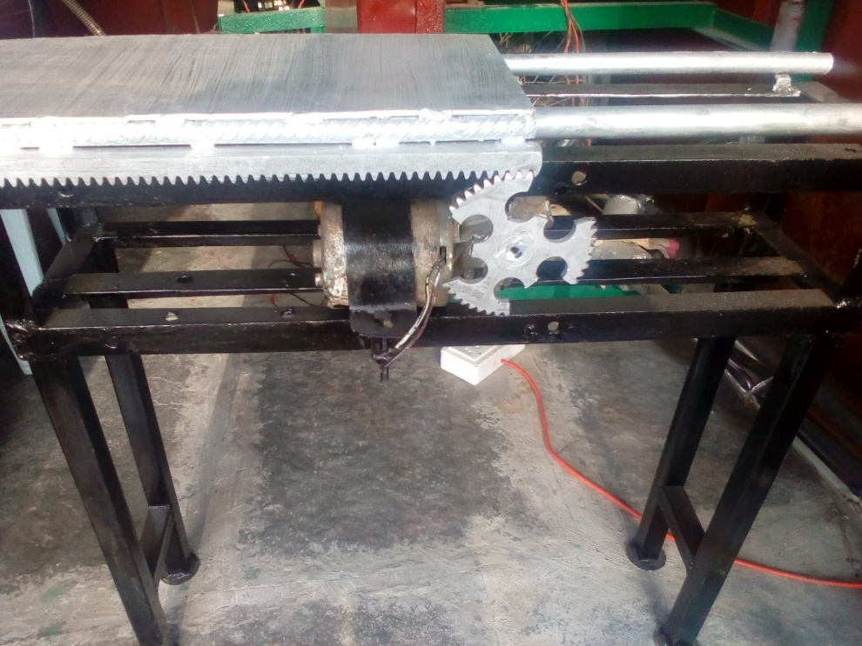

Fig. 4. 1 Construction Of Project

* 1. **WORKING OF PROJECT**

When we ON power supply of wiper motor for one direction then sector gear is rotate and when teeth engage with teeth of rack, the conveyor proceeds in one direction. When sector of gear un mesh with tack then conveyor stop. Again teeth of sector come in contact with rack and hence conveyor again proceed ahead. In that way due to engagement and disengagement of sector gear with rack, intermittent action of conveyor take place.

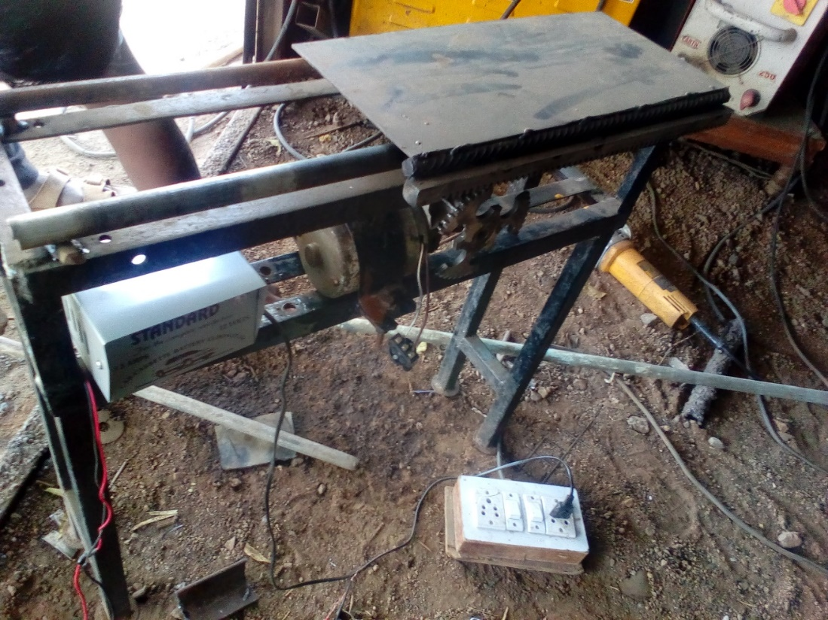

Fig. 4. 2.2 Working of Project

**Chapter No.-5**

**DESIGN OF PROJECT**

**5.1 MATERIAL SELECTION**

The proper selection of material for the different part of a machine is the main objective in the fabrication of machine. For a design engineer it is must that he be familiar with the effect which the manufacturing process and heat treatment have on the properties of materials. The choice of material for engineering purpose depends upon the following factors.

1. Availability of the materials.

2. Suitability of materials for the working condition in service.

3. The cost of materials.

4. Physical and chemical properties of material.

5. Mechanical properties of material.

The mechanical properties of the metals are those, which are associated with the ability of the material to resist mechanical forces and load. We shall now discuss these prosperities as follows. Required properties for the selection of material are Strength, stress, stiffness, elasticity, plasticity, ductility, brittleness, toughness, resilience, creep, hardness. The science of the metal is a specialized and although it overflows in to realms of knowledge it tends to shut away from the general reader. The knowledge of material and their properties is of great significance for a design engineer. The machine elements should be a material which has properties suitable for the conditions of operations.

The selection of the materials depends upon the various types of stresses that are set up during operation. The material selected should with stand it. Another criterion for selection of metal depends upon the type of load because a machine part resist load more easily than a live load and live more easily than a shock load. Selection of the material depends upon factor of safety which in turn depends upon the following factors.

1. Reliabilities of properties.

2. Reliability of applied load.

3. The certainly as to exact mode of failure

4. The extent of simplifying assumptions.

5. The extent of localized.

6. The extent of initial stresses set up during manufacturing.

The machine is basically made up of mild steel. The reasons for the selection are Mild steel is readily available in market .It is economical to use and is available in standard sizes. It has good mechanical properties i.e. it is easily machinable. It has moderate factor of safety, because factor of safety results in unnecessary wastage of material and heavy selection. Low factor of safety results in unnecessary risk of failure. It has high tensile strength. Low coefficient of thermal expansion. The materials of the sheets to be cut are taken as aluminium and plastic as they are replacing many metals in the present scenario because of their distinguished properties and features.

**Mild steel contains** –

Carbon 0.16 to 0.18 % (maximum 0.25% is allowable)

Manganese 0.70 to 0.90 %

Silicon maximum 0.40%

Sulphur maximum 0.04%

Phosphorous maximum 0.04%

Mildest grade of carbon steel or mild steel contains a very low amount of carbon - 0.05 to 0.26%

Properties of mild steel

Mild steel is the most commonly used steel. It is used in the industries as well in the different everyday objects we use. Even the pans and spoons of the kitchen are sometimes

made of mild steel. The main target of this article is to discuss about different mild steel properties. The mild steel is very important in the manufacturing of metal items. Almost 90% steel products of the world is made up of mild steel because it is the cheapest form of steel. Mild steel is the most widely used steel which is not brittle and cheap in price. Mild steel is not readily tempered or hardened but possesses enough strength.

The use of mild steel is huge and a person who is into manufacturing or production business need to know a lot about the important characteristics of mild steel. The study of mild steel becomes more significant for a student of mechanical engineering or metallurgical engineering. Mild steel is an alloy. And alloy is a product made by mixing metals and non-metals. Sometimes a pure metal cannot full fill all the properties needed for manufacturing product. So additives are included in the pure metal to obtain some specific properties necessary for the production. Mild steel is made by adding carbon and other elements in the iron. These elements improve the hardness, ductility and tensile strength of the metal.

Mild steel is a great conductor of electricity. So it can be used easily in the welding process.

Because of its malleability, mild steel can be used for constructing pipelines and other construction materials. Even domestic cook wares are made of mild steel. It is ductile and not brittle but hard.

Mild steel can be easily magnetized because of its ferromagnetic properties. So electrical devices can be made of mild steel.

Mild steel is very much prone to rust because it has high amount of carbon. When rust free products are needed people prefer stainless steel over mild steel.

**Chapter No.-6**

**MANUFACTURING PROCESS SHEET**

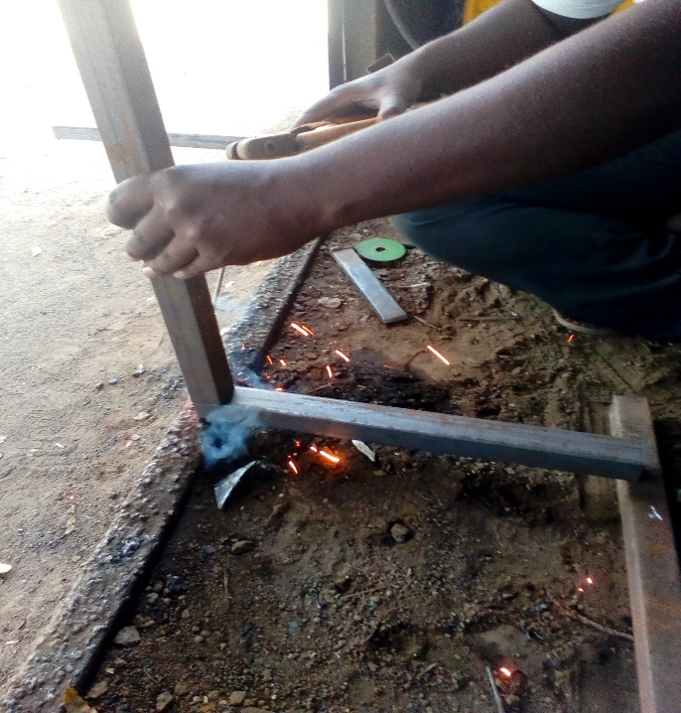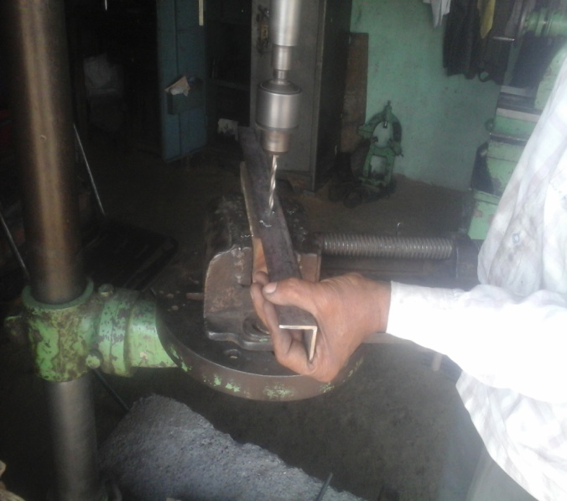

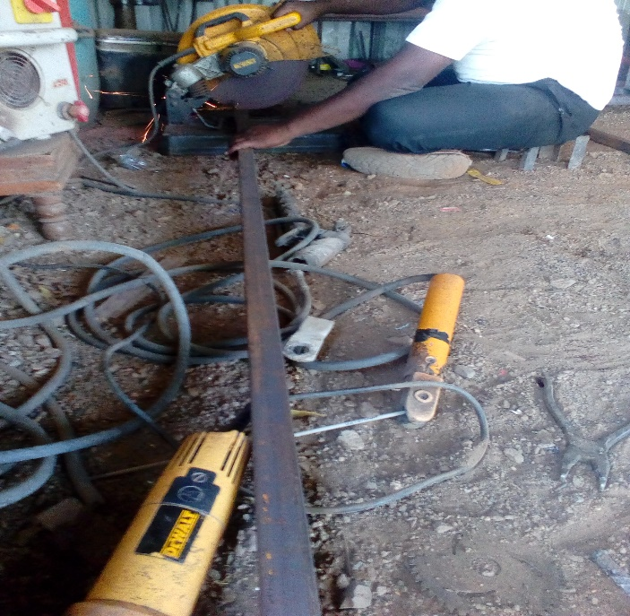 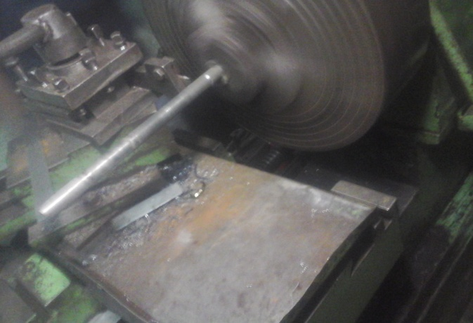

Fig. 6.1 Various manufacturing process related to project

**6.1 Frame**

**Row Material:** square Pipe

Angle 1”

Shaft 20 mm

Table 6.1 Process sheet of Frame

|  |  |  |  |  |
| --- | --- | --- | --- | --- |
| **Sr. No.** | **Process** | **Machine tool** | **Time** | **Cost** |
| 01 | Square Pipe cutting | Grinding Cutter | 15 min. | 150 |
| 02 | Angle cutting | Grinding Cutter | 10 min. | 120 |
| 03 | Shaft cutting | Grinding Cutter | 5 min. | 50 |
| 04 | Hole on angle | Drilling machine | 10 min. | 50 |
| 05 | Fabrication of all above | Arc Welding | 20 min | 300 |
| Total | | | 1 hr. | 670 |

**6.2 Conveyor Plate**

**Row Material:** Plate

Rack

Table 6.2 Process sheet of conveyor plate

|  |  |  |  |  |
| --- | --- | --- | --- | --- |
| **Sr. No.** | **Process** | **Machine tool** | **Time** | **Cost** |
| 01 | Bar cutting | Grinder Cutter | 10 min. | 20 |
| 02 | Sheet metal cutting | Grinder Cutter | 20 min. | 100 |
| 03 | Circular pipe cutting | Grinder Cutter | 10 min. | 80 |
| 04 | Fabrication of all above and rack | Arc welding | 20 min. | 200 |
| Total | | | 1 hr. | 400 |

**6.3 Intermittent Gear Mechanism**

**Row Material:** Shaft for motor

Table 6.3 Process sheet of Intermittent gear Mechanism

|  |  |  |  |  |
| --- | --- | --- | --- | --- |
| **Sr. No.** | **Process** | **Machine tool** | **Time** | **Cost** |
| 01 | Shaft cutting | Grinding cutter | 10 min. | 25 |
| 02 | Gear & shaft joining to motor | Arc welding | 10 min. | 25 |
| 03 | Gear sector cutting | Grinding cutter | 30 min. | 150 |
| 04 | Clamp for motor | Manual | 30 min. | 200 |
| Total | | | 1 hr. 20 min. | 400 |

**Chapter No.-7**

**COST ESTIMATION**

**7.1 BROUGHT OUT MATERIAL COST**

Table 7.1 Brought Out Material Cost

|  |  |  |  |  |
| --- | --- | --- | --- | --- |
| **Sr. No.** | **Name of component** | **Specification** | **QTY.** | **Cost** |
| 01 | Pipe | Dia.=20 mm bore | 1 feet | 200 |
| 02 | Wiper motor | DC motor | 1 | 1000 |
| 03 | AC to DC Convertor | 12 v | 1 | 500 |
| 04 | Shaft | 20 mm dia, | 6 feet | 350 |
| 05 | Square pipe | 1’’ | 20 feet | 450 |
| 06 | Rack & Pinion | Module=3mm | 1 | 1200 |
| 07 | Angle | 1’’width | 10 feet | 400 |
| 08 | Gear | Module=3 | 1 | 350 |
| 09 | Other (Nutbolt) |  |  | 200 |
| TOTAL | | | | 4650 |

**7.2 MANUFACTURING COST**

Table 7.2 Manufacturing Cost

|  |  |  |  |
| --- | --- | --- | --- |
| **Sr. No.** | **Manufacturing** | **Time** | **Cost** |
| 01 | Frame | 1 hr. | 670 |
| 02 | Conveyor plate | 1 hr. | 400 |
| 03 | Intermittent gear Mechanism | 1 hr. 20 min | 400 |
| TOTAL | 3 hr. 20 min | 1470 |

**BROUGHT OUT MATERIAL COST =4650**

**MANUFACTURING COST =1470**

**TRANSPORTATION COST =880**

**TOTAL COST =7000**

**Chapter No.-8**

**OUTCOMES OF PROJECT**

**8.1 ADVANTAGES**

1. Available in a wide variety of sizes.
2. Maintains good control of its load at all times.
3. Have little wear leading to a very long life span.
4. Low cost.
5. Saves Man Power.
6. Saves time.
7. Time delay can be achieved easily.
8. Convey the material at regular interval of time.
9. Easy setup in an industry.
10. Does not require stepper motor.
11. It use for heavy load

**8.2 LIMITATIONS**

1. Very difficult to change timing once design is chosen.
2. This means they produce jerk.

**8.3 APPLICATIONS**

1. Modern film projectors may also use an electronically controlled indexing mechanism or stepper motor, which allows for fast-forwarding the film.
2. Automated sampling devices.
3. Indexing tables in assembly lines, tool changers for CNC machines, and so on.
4. We can used this mechanism in bottle filling process.
5. It is applicable in the production industries and in automobile industries for mass production. Applicable where time delay is necessary in material handling
6. They were in many industries such as automotive, agriculture, bottling, food processing, aerospace and packaging.
7. They were used in industries for sorting, storing, pick up etc.

**Chapter No.- 9**

**FUTURE SCOPE**

The equipment can be implemented in a firm where loads are to be transported between stations. However they have few disadvantages, which can be overcome by further research and development of the project. To increase the distance covered by the model, reduction gears can be employed, so that the equipment can cover additional distance for every rotation of the model. In case of curved paths, the rollers can be adjusted at an angle with respect to the model. However this holds only for paths which are continuously curved i.e. having a certain radius and not involving any straight paths. To accompany various weights, the springs have to be designed accordingly. Thus this requires different spring design for different weights. Also by incorporating a dynamo in the model, it can generate power which may be used to run an electrical display or other electronic equipments mounted in the equipment. The dynamo can be operated by coupling its shaft to the pinion gear shaft.

**Chapter No.-10**

**CONCLUSION**

This project work has provide us an excellent opportunity and experience to use our limited Knowledge. We get lot of practical knowledge regarding planning, purchasing, assembling and machining while doing this project work. We feel that the project work is a good solution to bridge gap between the institution and the industries.

We are proud that we have completed work with limited time successfully. The actual working od Intermittent Conveyor System is satisfactory complete. We are able to understand the difficulties in maintaining the quality. We have done best of our ability and skills making maximum use of available facilities.

In that way due to engagement and disengagement of sector gear with rack, intermittent action of conveyor take place. Rack and pinion type of conveyor having more load carrying capacity than belt conveyor. It is applicable in the production industries and in automobile industries for mass production. Applicable where time delay is necessary in material handling. They were in many industries such as automotive, agriculture, bottling, food processing, aerospace and packaging.

**REFERENCES**

1. “Mini Conveyor Using Geneva Mechanism” Prof. (Dr.) S.V. Mukkawar1 , Aarya Mulay2, Shubham Mathur3, Abhishek Kakani4, Atharv Khutale5, Avinash Nair6, Shrey Merchant7, IJARSE April 2018.
2. “Design and Fabrication of Industrial Conveyor Using Crank Mechanism” N.Sivakumar1,K.Thamaraikannan2,R.Kalaiyarasan3,S.Veerakumar4,A.Vijay5,IRJET, Volume: 03 Issue: 04 | Apr-2016
3. “Design, Cad Modeling & Fabrication of Geneva Operated Roller Conveyor”, Mr M. V. Ingalkar1, Mr A. R. Sonekar2, Mr Y. D. Bansod3, (IJETT) – Volume-46 Number-2 -April 2017
4. “Design and Fabrication of Geneva Conveyor for Material Inspection & Noise Reduction”, E.Sanjay1 S.Pratheep Kumar2 P.Ranjith Kumar3 S.Nandha Kumar4 M.Mohamed Ajmal Mahasin5, IJSRD, Vol. 4, Issue 01, 2016
5. “Design Analysis of Conveyor Mechanism Unit for Local Operation of Automatic Car Park System”, N.A. Raji1, A.A. Ajasa2, A.A. Erameh3 and F.O. Ajayi3, Journal of Industrial Research and Technology Vol 3 • No 1 • 2011
6. R. S. Khurmi and J. K .Gupta, “A textbook of Machine Design”, S Chand Publication